Data Representation: Number Systems
im_number_systems.php — Information Management

Number Systems

A new kind of base…

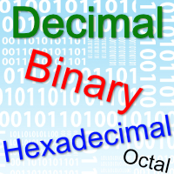
No we are not talking about your base in an RTS game.
Base here means the value that a specific number system is based on.
The three number systems used most in programming are Decimal, Binary and Hexadecimal (don't worry - each of these number systems is explained in all below + the extra bonus of Octal as well).


Why do we need different number systems?
Click the icon in the top right corner of this block to find out the answer.

The section above explained how computers see data as a series of switches and how we translate those switches into a binary number.
So Binary is necessary because it is as close as we can possibly get to a direct repressentation of the inner workings of a computer. That explains why we need binary as a number system.
Binary though is difficult to read and say.
Luckily someone worked out that two hexadecimal digits can be used to describe the same range of numbers as eight binary digits (i.e. 0 - 255). The hexadecimal digits have the advantage of being shorter as well as being easier to read and say.
Hexadecimal is a kind of 'short hand', quick and easy representation of the value of a Byte. That is why we need hexadecimal as a number system.
Octal represents the same range of numbers as 3 binary digits (i.e. 0 - 7).
Click the icon in the top right corner of this block to find out the answer.

Which is which - identifying the number system we are using
When working in an environment that uses different number systems (like programming) you need a quick an easy way to show which number system is being used.
1010 could be ten (in binary) or one thousand and ten (in decimal) or even 4112 (in hexadecimal).
There are two ways to make this differentiation:
- Write the base of the number in bracketed subscript after the number.
E.g. 1010 (2) is a binary number and 1010 (10) is a decimal number. 1010 (16) is a hexadecimal number.
Often the base is left out for a decimal number, which means that if there is no base indicated you can assume the number is decimal.
Put a prefix in front of the number
if the number is not decimal.
E.g.
0b1010
is a binary number - indicated by the 0b at the start of the number.
0x1010
is a hexadecimal number - indicated by the 0x at the start of the number. 1010 is decimal because it has no prefix.
The second option is the one preferred by most programmers.
Decimal
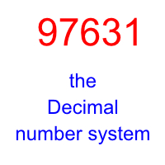
Decimal is the number system we use all the time.
Its base is the number 10 - do the decimal number system is also known as
Base 10.
We will look at converting between decimal and the different number systems in the specific number system sections.
For most people numbers will only have meaning when converted back to decimal.
Even seasoned programmers who can easily read and understand Binary and Hexadecimal subconsciously do a conversion back to decimal when they are trying to understand a number.
Return to the top of this panel
Binary
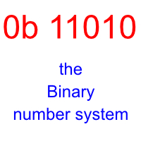
Binary is the number system that most closely resembles the contents of memory and storage in a computer.
The number system is also known as Base 2.
Most programmers prefer to use Hexadecimal instead of binary because it is shorter and easier to read but also perfectly represents 1 (or more) bytes of data.
Step By Step Guide to converting Binary to Decimal
The quickest way to convert…
Complete!
Congratulations you have completed all of the steps successfully
Binary to Decimal Step 1
Write down the binary number with some spaces between the digits.
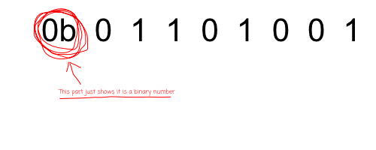
Binary to Decimal Step 2
Start beneath the rightmost digit of the binary number.
Write down a '1'.
Now work your way right and multiply the previous number by 2.
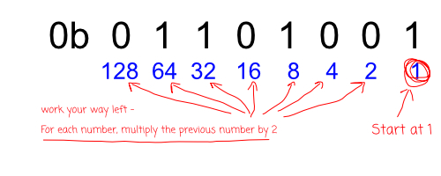
Binary to Decimal Step 3
Now simply add all the decimal numbers with a binary '1' above them together…
That's it. All done!
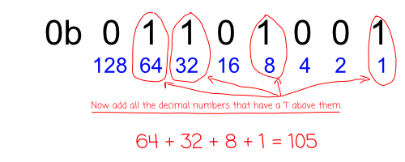
Of course, you also need a way to convert decimal into binary - for when you need to get a decimal number into a for the computer can understand.
Step By Step Guide to converting Decimal to Binary
The quickest way to convert…
Well Done!
Congratulations!
You now know how to convert a Decimal number to Binary.
Decimal to Binary Step 1
Write down the decimal number and divide it by 2.
Write down the answer.
If the two does not divide into the number perfectly, write down the remainder (which is 1) as in the picture below.
NB: If the two does divide perfectly you still have to write down the remainder (which is 0).
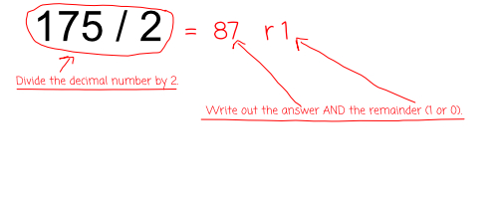
Decimal to Binary Step 2
Repeat what you did in step 1 - to the answer of that calculation.
Keep on repeating until you reach the line
1 / 2 = 0 r 1
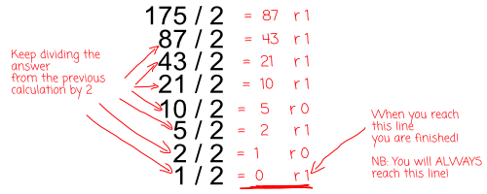
Decimal to Binary Step 3
Write down the remainders as a number - starting from the bottom up.
NB: The bottom remainder is the left digit of the new number.
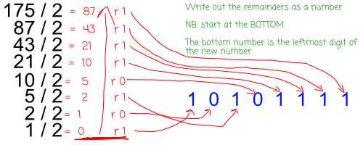
Return to the top of this panel
Hexadecimal
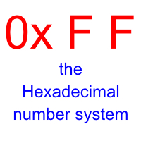
TWO Hexadecimal digits can represent a range of numbers between 0 - 255. This makes it able to represent 8 binary digits - which is also 1 byte of data.
The number system is also known as Base 16.
Most programmers prefer to use Hexadecimal instead of binary because it is shorter and easier to read.

Counting in Hexadecimal
Hexadecimal has 16 digits.
We can start counting at 0 - just like all number systems.
When we get to 9 we have a problem.
We have covered values from 0 - 9 but have now run out of numerical symbols. So we simply start using the alphabet.
A represents 10
B represents 11
C represents 12
D represents 13
E represents 14
F represents 15
Now we have finally used 16 digits, and just like any other number system we reset the current column to 0 and add 1 to the column immediately on the left.
The animated gif below shows this type of counting at work…

Step By Step Guide to converting Hexadecimal to Decimal
The quickest way to convert…
Complete!
Congratulations!
You should now know how to convert a Hexadecimal number into Decimal.
Hex to Decimal Step 1
Write down the Hexadecimal number with some spaces between the digits.
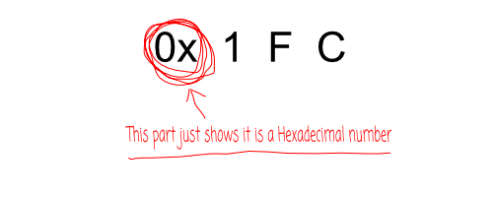
Hex to Decimal Step 2
Start beneath the rightmost digit of the hexadecimal number.
Write down a '1'.
Now work your way right and multiply the previous number by 16.
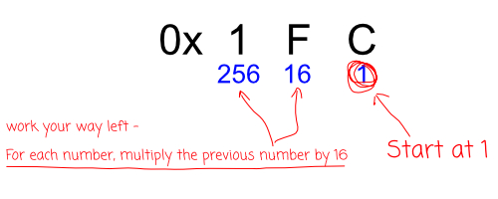
Hex to Decimal Step 3
Now simply multiply the hexadecimal value by the number beneath it - and then add all the results together…
That's it. All done!
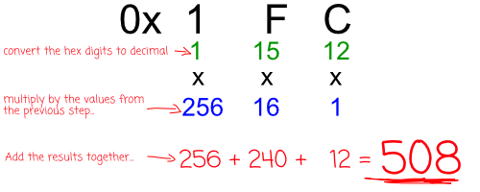
Of course, you also need a way to convert decimal into hexadecimal - for when you need to get a hex number.
Step By Step Guide to converting Decimal to Hexadecimal
The quickest way to convert…
Well Done!
Congratulations!
You now know how to convert Decimal to Hexadecimal.
Decimal to Hex Step 1
Write down the decimal number and divide it by 16.
Write down the answer.
You must write down the remainder (even if it is 0) as in the picture below.
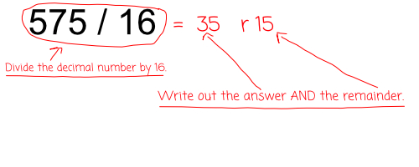
Decimal to Hex Step 2
Repeat what you did in step 1 - to the answer of that calculation.
Keep on repeating until you reach the line
number / 16 = 0 r number
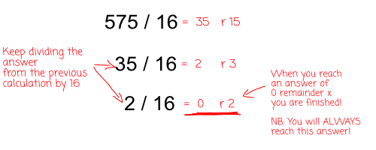
Decimal to Hex Step 3
Write down the remainders as a number - starting from the bottom up.
NB: The bottom remainder is the left digit of the new number.
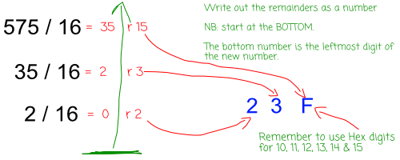
Return to the top of this panel
Octal
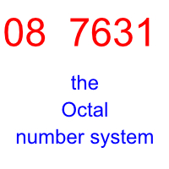
The number system is also known as Octal.
Octal is seldom used today because hexadecimal is better for representing 8 bit, 16 bit, 32 bit and 64 bit numbers.
It is NOT included in the CAPS but is included here for interest and to show that the conversion methods you have learnt apply to any number system!

Counting in Octal
Octal has 8 digits.
We can start counting at 0 - just like all number systems.
When we get to 7 we have run out of digits.
Just like any other number system we reset the current column to 0 and add 1 to the column immediately on the left.
Step By Step Guide to converting Octal to Decimal
The quickest way to convert…
Complete!
Congratulations!
You should now know how to convert a Octal number into Decimal.
Octal to Decimal Step 1
Write down the Octal number with some spaces between the digits.
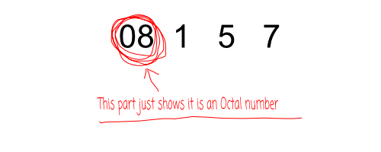
Oct to Decimal Step 2
Start beneath the rightmost digit of the octal number. Write down a '1'. Now work your way right and multiply the previous number by 8.
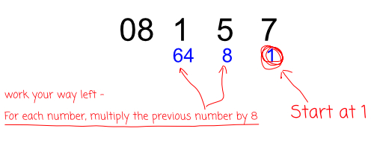
Oct to Decimal Step 3
Now simply multiply the octal value by the number beneath it - and then add all the results together…
That's it. All done!
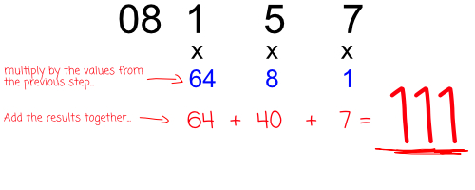
Of course, you also need a way to convert Decimal into Octal - for when you need to get an octal number.
Step By Step Guide to converting Decimal to Octal
The quickest way to convert…
Well Done!
Congratulations!
You now know how to convert Decimal into Octal.
Decimal to Octal Step 1
Write down the decimal number and divide it by 8.
Write down the answer.
You must write down the remainder (even if it is 0) as in the picture below.
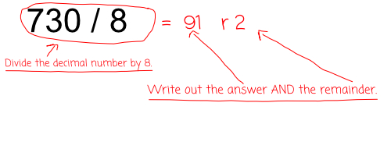
Decimal to Octal Step 2
Repeat what you did in step 1 - to the answer of that calculation.
Keep on repeating until you reach the line
number / 8 = 0 r number
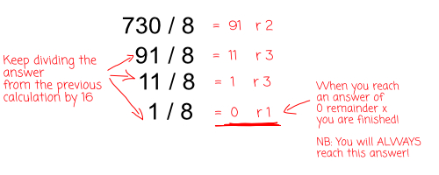
Decimal to Octal Step 3
Write down the remainders as a number - starting from the bottom up.
NB: The bottom remainder is the left digit of the new number.
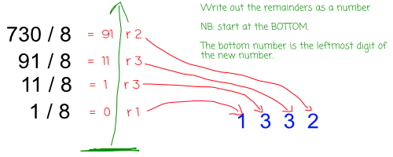
Return to the top of this panel

Video Links - Number Systems (Binary, Hexadecimal, Octal)
We have selected and curated a set of videos on YouTube related to your course.
These videos are not created or owned by us.
They may display advertising and in some cases may contain limited amounts of swearing.

Notes for this Module
What to look out for and do in this module...

FAQs for this module
Questions on Number Systems - and their answers...

Network Types FAQ
View the questions or type in the term you are looking for below…
No results were found

Why is Binary so important?
Because it is the most direct representation of the state of computer memory (remember, memory is nothing but a series of switches that can only be on or off).

What's the big deal about Hexadecimal?
Working with, reading and saying binary can be awkward. The numbers are too big and don't roll off the tongue easily.
Two Hexadecimal digits represent every possible value in a Byte and are much easier to say and (if you practise) understand.
Hexadecimal works as a kind of shorthand for representing the value of a Byte.

Why learn Octal?
Most people don't bother - but Octal is still used - for example the attributes of files in Linux are represented by Octal numbers (i.e. who can read / write / execute a file).

Where am I most likely to work with Hexadecimal?
Colour values (especially in web design) are represented in Hex.
You will often also find Hex in character tables (e.g. ASCII / Unicode) and in error codes.
If you ever use a tool to look at the contents of memory or of a file on storage those contents are most likely to be shown to you in Hex because a long string of Binary is sure to cause your eyes to glaze over.

Do people really work in Binary?
Yes - especially designers of hardware and circuits.

